Solutions

(1a) In one dimension 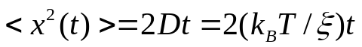. Hence time to diffuse distance R: 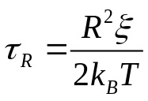
Time to sediment a distance R is: 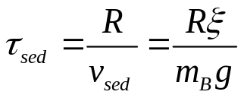
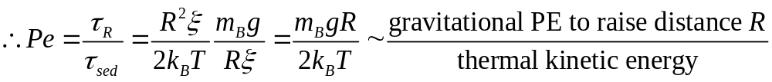

(1b) Every particle has thermal energy Etherm = (3/2) kBT and potential energy
Epot = mgz = (4π/3) R3Δρgz, where z is a characteristic length, e.g. R, and Δρ is the density difference between the particle and the solvent. For a significant influence of the thermal energy we need Epot < Etherm and thus for (Δρ ≈200 kg/m³: R < (9kBT / 8πΔρ g)1/4 ≈ 0.93 µm.

(1c) All or some of the following points will be found in a good answer.

At moderate particle densities, the positions begin to become correlated as the

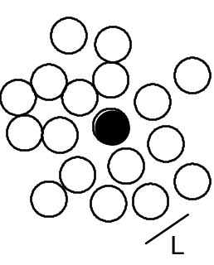
particles are mutually excluding. If we look inside a suspension of volume fraction φ ≥ 0.3, then we will find that, at any one instant, each particle is surrounded by a `cage’ of neighbours (short-ranged order). The cage tightens as φ increases. The cage size represents a dominant length scale in the system.

Despite the appearance of correlations between particle positions, a hard-sphere suspension below φ <0.5 is still in what one might call a 'colloid fluid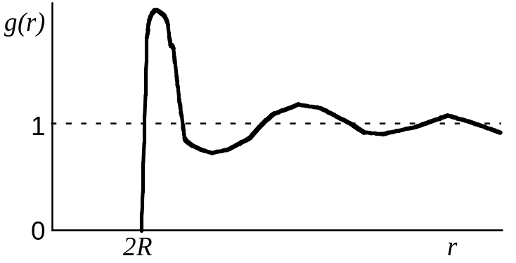' phase, i.e. the arrangement of particles in such a suspension is analogous to the arrangement of atoms in an atomic fluid (e.g. fluid argon) - on average the particle centres are more or
less randomly arranged, and each particle can, given time, wander through the available volume. The structure is described by the radial distribution function g(r). Given a particle centred at r = 0, (N/V)g(r)dr is the number of particles in dr at a distance r. If we increase the volume fraction above φ ≈ 0.55, however, a phase transition occurs. The particles will spontaneously pack into a crystalline arrangement. Particles now can only move round about their average lattice site, but will not wander throughout the available volume. This phase is called a 'colloidal crystal'. Due to more local freedom the crystal has a higher (!) entropy than the metastable fluid from which it grows. It is an entropically-driven phase transition. Between φ=0.5 and φ=0.55, we find coexistence between colloidal fluid and crystal.
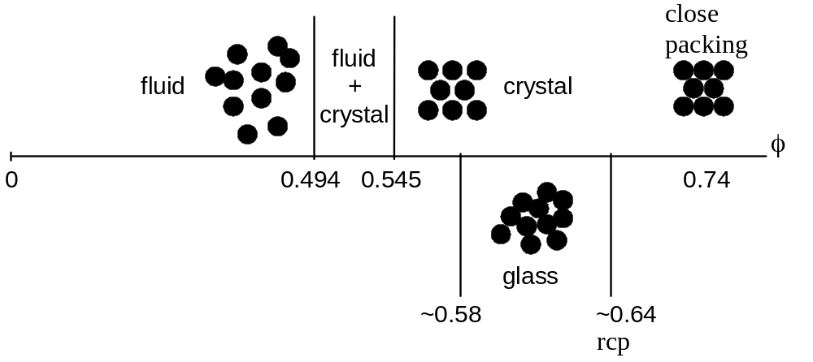
Note that no colloidal liquid is formed (Tc = 0), as expected for an interaction potential without attraction.Above φ ~ 0.3, however, different regimes are observed. At short times the particles diffuse with the short time (self) diffusion constant Ds. This is determined from the
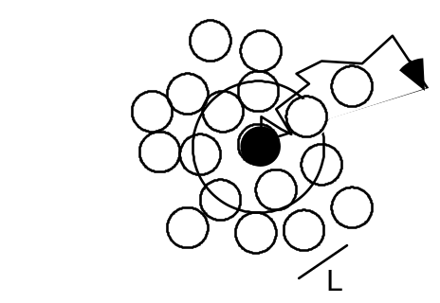
short time limit and is smaller than the D0 measured for φ → 0. The motion of the particles (self diffusion) is still driven by collisions with the liquid molecules, but in addition the interactions between particles become significant. While the particles are diffusing in their cages formed by their neighbours, the hydrodynamic interaction with the neighbours, transmitted through flows in the liquid, causes slowing down relative to the free diffusion at low concentrations. At intermediate times the particles encounter the neighbours and the interactions slow the motion down. To make further progress, the particle has to break out of the cage formed by its neighbours. Now the particles experience a further interaction, direct interactions (hard-sphere interactions), in addition to the hydrodynamic interactions. The long-time and long-ranged movement is also diffusive, i.e. we still have <r2(t)> ∝ t, when the particles undergo large-scale random-walk diffusion through many cages. However, the motion is further slowed and a smaller diffusion constant relative to the motion in the short time limit is observed, the long time (self) diffusion constant DL.

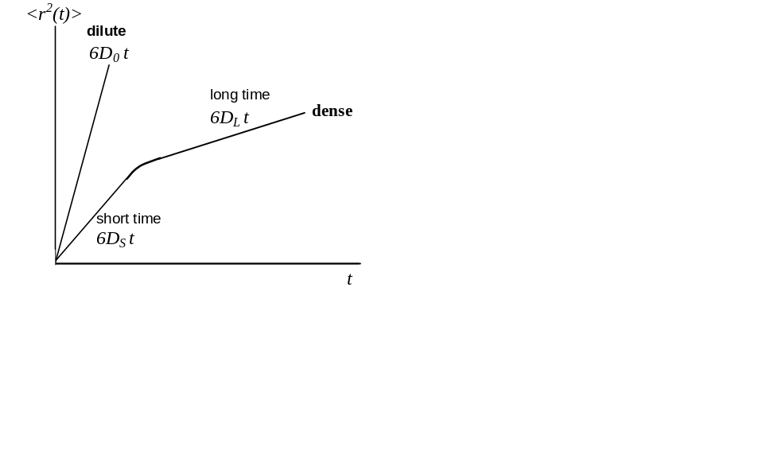
x10²⁰ years.

(2a) The fact that two monomers cannot occupy the same space has consequences on different length scales. On a local length scale this prevents neighbouring monomers from coming too close together. This effect is taken into account in terms of a restricted bond-angles, which prevents them from overlaping. Non-overlap, i.e. excluded volume, of distant monomers along the chain has also to be taken into account and can have surprisingly large effects.

To estimate the importance of this effect, we consider the fraction of coil volume actually occupied by monomers:
volume actually occupied by monomers: 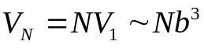
(where V1 is the volume of a monomer)
volume occupied by the whole coil: 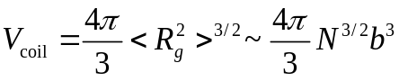
∴ 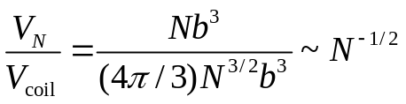
e.g. N = 104 monomers occupy only about 1% of the whole coil volume.

The overall chain size <Rg2>1/2 is determined by the competition of two effects. Entropy (and chain connectivity) favour a compact chain and avoid the more unlikely stretched configurations, while repulsive excluded volume interactions want to expand the chain to avoid overlap. Based on this balance we will 'calculate' the effect of excluded volume in a very hand-waving way. (Due to a fortuitous cancellation of errors introduced by various approximations, the result is practically identical to more rigorous treatments, which are very involved.)
We consider the Helmholtz function of a single chain, which is regarded as an assembly of particles with constant volume NV1 at constant temperature T:
F = U - TS
The entropy S is given by
S = kB ln(no. of configurations)

where for a given R the number of configurations is expected to be proportional to
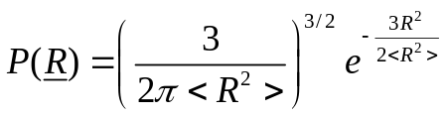
and hence
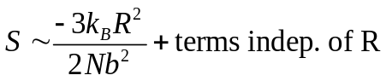
The internal energy U includes the kinetic and potential energy. However, the kinetic energy is independent of the configuration and thus of R and we only have to consider the potential energy. To estimate the potential energy, we disregard the connectivity of the chain and calculate the interaction energy of a 'segment gas' confined in a volume R3. The probability of a monomer to lie in this volume is given by the fraction of total coil volume occupied by monomers, which we estimated above to be 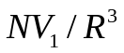. Thus the probability of monomer-monomer contacts is 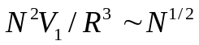. With an energy ε of a monomer-monomer contact, the potential energy 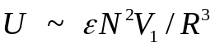.
We thus obtain
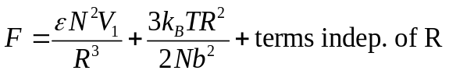
which can be minimized with respect to R, i.e. dF/dR = 0, yielding
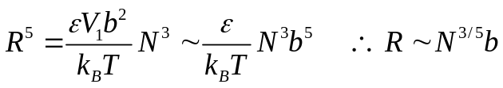

(2b) The importance of solvent-monomer attractions generally depends on temperature. At very high temperatures the coil is expanded and the solvent quality is good. In contrast, at very low temperatures, the solvent quality is poor, attraction dominates, the coil collapses and phase separation is observed. In between these two limits, there is a temperature, the so-called theta temperature Θ, where the coil has ideal dimensions and the effects of excluded volume and attraction cancel each other. The solvent at T = Θ is called a 'theta solvent'. The stronger the attractions the higher Θ will be, while for weak attractions Θ is low.

(2c) At T = Θ, the rms end to end distance is R=bN^{0.5}, while for T >> Θ, the chain is swollen and R=bN^{0.6}. Sticking in the numbers we get R=63.2nm and R=200nm respectively.

(2d) Overlap occurs when the volume fraction of coils reaches unity and thus
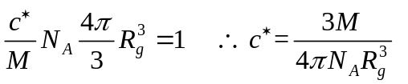

(2e) In the first case of the theta solvent, sticking in the numbers we get c*=15.67 kg/m³, this reduces to c*=0.495 kg/m³ in the good solvent (swollen chain) case. Thus in the good solvent case, overlap is reached for much lower concentrations.

